The directions to convert PowerPoint to outline for Braille or notes
- Check each slide first to make sure pictures have a description or if there is words within the picture that it is placed outside the picture on the PowerPoint slide. If there are jpeg charts and graphs that are jpeg, they need to be converted to the PowerPoint chart or described. Whichever is better for the meaning of the chart. Typically you do need to provide a new slide and redo the chart.
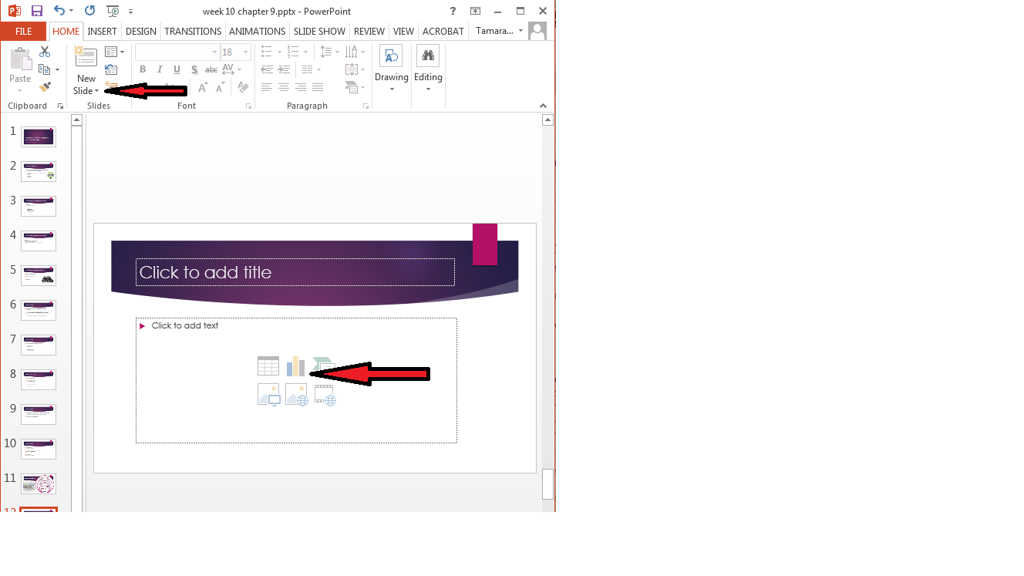
- After this is complete convert the PowerPoint into an outline.

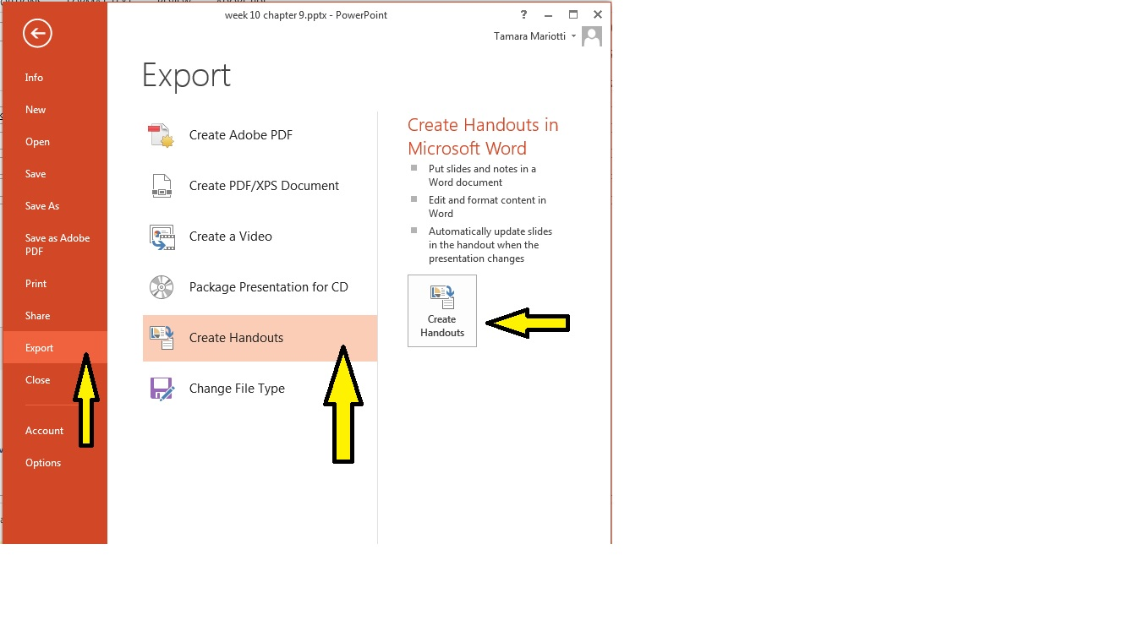

CHOOSE OUTLINE ONLY!!!

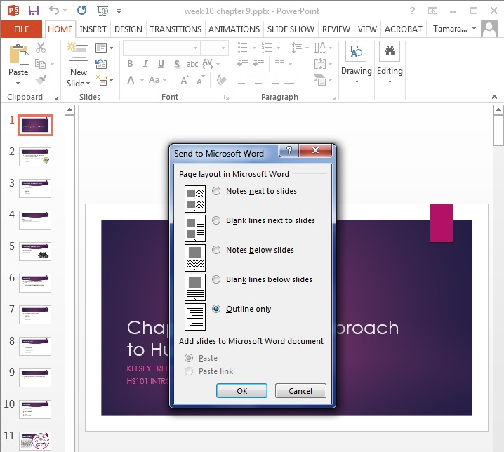

- This will create a “RAW” outline

- Chapter 9: A Family Approach to Human Services
- Kelsey Freeman, ms, lmhc, casac
- Hs101 intro to human services
- What is a family?
- “A primary group whose members assume certain obligations for each other and generally share common residences”
- Idea of family is changing
- It is important to understand and identify members of the family unit
- Always ask
- What are the responsibilities of a family?
- Child care
- Financial support
- Care and nurturing

For Braille, there should not be any bullets use numbers and letters, 1. 2. a. b. c. etc., and there is no need to have increased font, everything should be at 12 font from the title, to the information. Headings are important as well for the “digital file”. So if they want to go from heading to heading they can. So each “section” would be heading 1, then after that normal or heading 2.
