WELCOME TO BUFFALO

Double Decker Tour bus
Members of the WNY CCDA have gathered information on tours in Buffalo. All attendees are welcome to choose from the options available.
Double Decker Tour Bus Please sign up prior to the day of the event.
Cost: $28.00

Departs from Hotel Henry at 5:45pm June 25th, 2019
Experience the best of Buffalo aboard an authentic British Double Decker Bus. During this private tour reserved exclusively for NYSDSC delegates you'll explore the amazing story of Buffalo's turbulent history as it rose from being a notoriously crime ridden waterfront village to its days as the 8th largest city in the nation. After departing from your hotel, guests will see Buffalo's grand mansions, renowned architecture and waterfront grain silos. Your host is Officer O'Connor, an Irish cop transported from the 1800's to provide all the best stories of lives, love and loss during this 90 minute tour. All aboard for a humorous and historic experience!
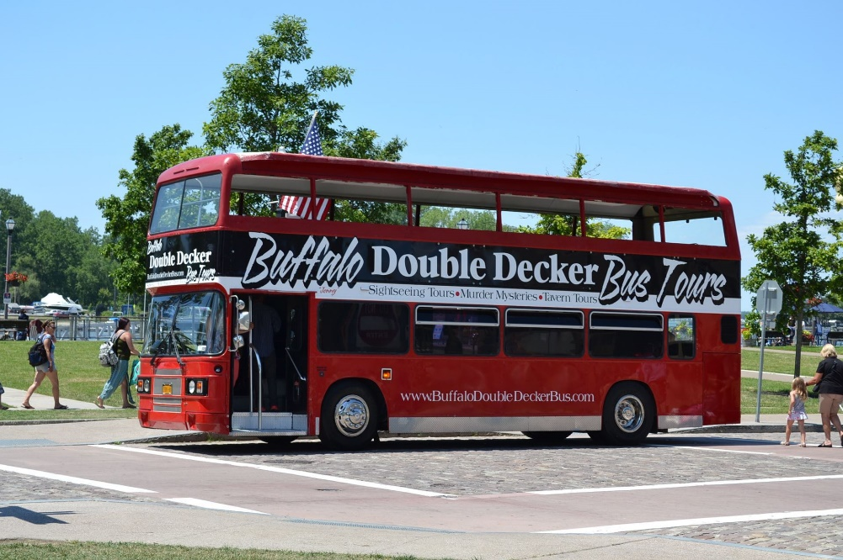

Attractions in and around Buffalo
This flyer will provide you information on the Canalside, Larking Square, Elmwood Village, Allentown, Kayaking, Niagara Falls, Beer in Buffalo, and Pedal Tours. There are many activities in the surrounding areas. Elmwood, the street that Hotel Henry is on, has many places to eat and provides a wide variety of restaurants and ethnic foods to choose from.

