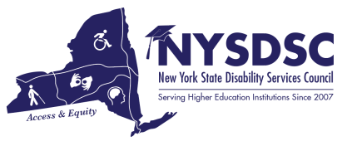

**Submission Date:**

6/30/2022

**Name of the Committee:**

AHEAD

**Committee Chair**:

Gabriella Vasta, SUNY Delhi

# Name of Committee Members and Affiliations:

Gabriella Vasta, SUNY Delhi

# Committee’s Goals and Objectives:

# Objectives In-progress/Pending:

# Objectives Achieved: (summary)

# The upcoming conference is in Ohio (Cleveland from July 18th to 22nd 2022). AHEAD is also offering a virtual mini conference August 2-4th this conference will highlight some of the topics from the Cleveland conference and will include a recording from the Keynote speaker.

# There will be a silent auction this year. Katherine Daley from SUNY Upstate will be bringing our basket for the auction.

# The reauthorization forms were submitted April 30th which renewed our liability insurance.

# There are few board positions available open, one for President- elect and two Director at large positions

# AHEAD will also be working on its new Strategic Plan.

# Upcoming Professional Development

# Look for updates about Fall professional development.

# Usually a webinar series and Tech Conference (Accessing Higher Ground)

# Announcements:

# Questions or Concerns:

# Additional Notes: