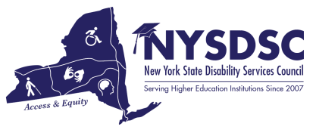

**Submission Date:**

6/22/2022

**Name of the Committee:**

Website Committee

**Committee Chair**:

Gabriella Vasta, SUNY Delhi

# Name of Committee Members and Affiliations:

* Tamara Mariotti, Mohawk Valley Community College
* Kala Rounds, Syracuse University
* Catherine Carlson-Columbia Greene Community College
* Gabriella Vasta, SUNY Delhi

# Committee’s Goals and Objectives:

Provide regular website maintenance and communications for New York State Disability Services Council professionals.

# Objectives In-progress/Pending:

# Continue to update the content and communications via the website for NYSDSC Professionals.

# Objectives Achieved: (summary)

* NYSDSC renewed the domain name “NYSDSC.org”. We had to get the domain changed from Michele Fish to Nancy Carr in 2020. There was a tremendous amount of time and paperwork with this change and Nancy Carr had to have a background check, etc.  We use Just Host as a hosting site, which also works with our domain. The domain is up for renewal on August 14, 2022. The NYSDSC email is also through the Just Host site. To exist on the internet, the data that makes up every web page must be stored somewhere. A web hosting service is provided by a company—known as a web host or web host provider— that owns servers and offers you the chance to rent space on one of them to create, store, and maintain your website online. We use Just host. This also provides us with an IP address and server. Pro Web Hosting through Just Host is up for renewal on 12/10/23. Some of our security is up for renewal on 12/10/22. The committee will be discussing these updates this upcoming year.
* Our website is still facing the public through Wild Apricot at this time and has the features that we require for online payment and membership along with the coordination of the events, and it has been paid for without any interruptions in services this year. The cost did increase this year as we decided to increase the current account plan membership limit to 500 people. US$ 2244.00 / 2 years; the Next renewal date is February 22, 2024. We will be looking into changing the NYSDSC domain ownership so that the responsibility doesn’t fall on one person but rather on the organization.

* There is always a need for any members that are interested in supporting the website, making changes to the website as needed, and working with the Website committee. If any members are interested please reach out to me.
* Continue Supporting the customer experience and business reputation of NYSDSC through the website
* Continually troubleshoot through regular monitoring that the website is performing well.
* Website framework maintenance – regularly keeping up with security updates, fresh content, encouraging traffic growth, and making sure your website visitors are happy.

# Announcements:

# Questions or Concerns:

# Additional Notes: