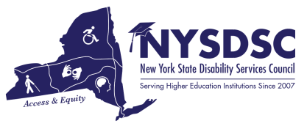

**Submission Date:**

6/14/2022

**Name of the Committee:**

Awards

**Committee Chair**:

Catherine Carlson, Columbia-Greene Community College

# Name of Committee Members and Affiliations:

Catherine Carlson, Chair, Columbia-Greene Community College; Vanessa Case, Paul Smith’s College; Jean Vizvary, SUNY New Paltz; Debbie Dimitrovski, Daemen College; Kris Percival, St. Joseph’s College of Nursing; Jessica Burnett, SUNY Potsdam

# Committee’s Goals and Objectives:

To select NYSDSC members and partners who have demonstrated commitment within the field of Disability Support Services, and to acknowledge exemplary contribution to the field while actively advocating for the inclusion, equity and dignity of students with disabilities in higher education.

# Objectives In-progress/Pending:

In the immediate term, the Planning Committee is polling the membership to determine the post-pandemic resources available for future events.

# Objectives Achieved: (summary)

The Committee began with revising the Charge to be consistent with the new NYSDSC Strategic Plan.

The Committee then revised the Awards Categories to align with the new Strategic Plan and in response to requests from members to bring back the New Professional category and develop a new category in relation to the intersection of disability and diversity, equity and inclusion. The new award categories developed are: Collaboration, Diversity and Equity, Service to NYSDSC and New Professional. Criteria descriptions and past award recipients are on the NYSDSC Committees web page. A call for nominations was sent to the membership, nominations were reviewed by the Committee and recipients were selected. The Awards Committee also recommended that the Executive Committee consider an award for “Excellence in Activism” for a member who performed exemplary skills in activism in 2022. Awards were ordered and nominators and nominees were notified of the decisions. Physical awards were ordered, to be presented at the NYSDSC Spring 2022 Conference on June 29, 2022.

# Announcements:

Award recipients will be announced at the Spring 2022 Conference on June 29, 2022.

# Questions or Concerns:

None

# Additional Notes:

None