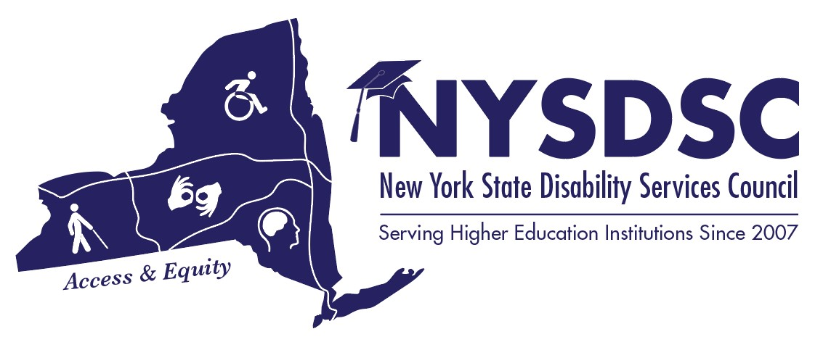
New York State Disability Services Council
Fall 2017 Meeting
BUILDING RESILIENCE, EMPOWERING LIVES
AGENDA

Day 1: Thursday, November 9th, 2017

08:30 to 09:25 am Registration and Full Breakfast
Grand Ballroom SALON AB

09:30 to 09:55 am Opening Remarks, Loren Nowak, NYSDSC President
Grand Ballroom SALON D

10:00 to 11:25 am Maintaining Health and Wellness as a DSS Provider
Grand Ballroom SALON D
Don Pool, LMSW, Coordinator of Accessibility Services
Jamestown Community College

We will explore together the hazards of our profession and answer questions such as:
How do I keep my sanity, especially at the beginning of the semester?
How do I avoid being a “helicopter professional”?
How do I avoid secondary traumatization?
Many professions now understand the importance of self-care and wellness. As professionals working closely with vulnerable and fragile individuals our lives and wellbeing depend on taking care of ourselves and keeping well. In this session, we will explore the reasons we must practice self-care and a explore variety of ways where we can accomplish balance and wellness in our lives.

11:30 to 12:55 pm Open Dialogue: I have a Student /faculty/parent who….
Facilitated by Carolyn Boone, Tompkins Community College
Grand Ballroom SALON D

Bring questions, present an issue, or simply come to listen! Here’s your
opportunity to draw on the experience and expertise of your colleagues who “have
been there; done that”.

01:00 to 01:55 pm Lunch SALON AB

02:00 to 3:25 pm NYSED Advisory Council on Post-Secondary Education for Students with Disabilities Update:
Tamara Mariotti, Coordinator of the Office of Accessibility Resources (OAR) Mohawk Valley Community College, Co-Chair NYSED Advisory Council for SWD in Post-Secondary Education
Kevin Smith, Deputy Commissioner, ACCES-VR;
Joanne LaCrosse, Policy and Professional Development Coordinator for NYSED Special Education Policy & Quality Assurance;
Stan Hansen, Assistant Commissioner for the Office of Access, Equity, and Community Engagement Services at NYSED.

Grand Ballroom SALON D

Learn what is timely and relevant to disability professionals in New York State
Including State funding, programs that affect our students, Excelsior Scholarship and Readers Aid. Come prepared with questions!

03:30 to 03:40 pm Break

03:45 to 05:15 pm Sector Meetings

CUNY – Troy Room
SUNY - Salon C
Proprietary – Schenectady Room
Independent – Schenectady Room

05:30 to 06:30 pm Happy Hour – Chat’s Lounge - New members are encouraged to attend!

Day 2: Friday, November 10th, 2017

08:15 to 09:10 am One-Day Registrations Full Breakfast/ Committees
Grand Ballroom SALON D

09:15 to 09:55 am NYSDSC Business Meeting
Grand Ballroom SALON D

10:00 to 10:30 am Reader’s Aid – What to know for this year and review of any procedure changes.
Grand Ballroom SALON D
Dennis Barlow, NYSED - ACCES-VR specializing in NYSED Reader’s Aid Program; Tamara Mariotti – Coordinator of the Office of Accessibility Resources (OAR) Mohawk Valley Community College, Co-Chair NYSED Advisory Council for SWD in Post-Secondary Education
Ceylane Meyers-Ruff, Director of VR Central Office Administration ACCES-VR

10:35 to 10:45 am Break & Refreshments

10:50 to 11:20 am Let’s look at our Data – 2H2 reports
Grand Ballroom SALON D
Enrollment of College Students with Disabilities recent changes to the data forms on the 2-H2 reports will be reviewed from NYSED information. Every institute provides this data.
Dr. Leigh Mountain, NYSED- Associate in Education Research

11:25 – 1:00 pm Concurrent Sessions

3.1 An Introduction to Web Accessibility
SALON B
Mark Greenfield, Digital Strategist, State University at Buffalo

Web accessibility can be defined as making sure websites work for the widest possible audience. While the focus is on people with disabilities, the core principle is inclusion. The goal is to create web sites that more people can use effectively in more situations. In this presentation, Mark will introduce web accessibility and why it matters, give a brief overview of the legal landscape, demonstrate tools and techniques to identify accessibility issues, and provide a framework for creating a web accessibility program.

3.2 Autism 201: Paul Meier, CNY Autism Consulting
SALON C
Abstract: Gain a working knowledge of the "operating system" of autism so that interactions and supports with those on the autism spectrum can have increased success. Will create a better understanding of why things happen the way they do with an autistic student, and how differing responses and supports will impact that student. This will allow reverse engineering of situations back to their basic core causes, and address supports to meet the core needs, rather than at an observable symptomatic level. Paul Meier is on the autism spectrum himself. Will make time for questions, and be available after for further discussion.

