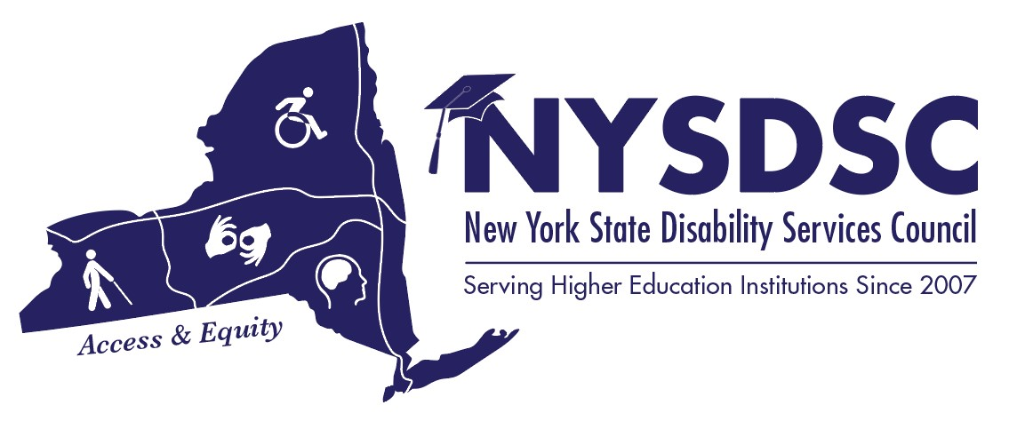
New York State Disability Services Council
Fall 2018 Meeting

AGENDA

Day 1: Thursday, November 29th, 2018

08:30 to 09:25 am Registration and Full Breakfast
SALON E

09:30 to 09:55 am Opening Remarks, Catherine Carlson, NYSDSC President
Grand Ballroom SALON D

10:00 to 10:55 am Reimagining Disability Support, from a Logistical Standpoint
Grand Ballroom SALON D
Christopher Leydon, Coordinator
Office of Student Disability Services
CUNY School of Professional Studies

11:00am to 12:25pm Updates from the New York State Education Department:
Grand Ballroom Salon D
Kevin Smith, Deputy Commissioner, ACCES-VR;
Leigh Mountain, NYSED-The Office of Information and Reporting Services
Kelly Onorato, NYSED- Office of Special Education Policy.
Tamara Mariotti, Coordinator of the Office of Accessibility Resources (OAR) Mohawk Valley Community College, Co-Chair NYSED Advisory Council for SWD in Post-Secondary Education

Learn what is timely and relevant to disability professionals in New York State, including P-12 Special Education initiatives that effect our students, NYS ACCES-VR updated funding formula, data collection, legislative updates. Come prepared with questions!

12:30 to 01:25 pm Lunch
Salon E

01:30 – 02:25 pm Concurrent Sessions

  - Open Networking Activities
TROY ROOM

Designed to get you up and moving and interacting with one another

2.1 Social Model – How Does that Actually Happen?
SCHENECTADY ROOM
Christopher Leydon, Coordinator
Office of Student Disability Services
CUNY School of Professional Studies

A workshop involving practical suggestions and role playing as to how the Social Model plays out in our offices and on our campuses.

2:30 – 3:55 pm The Legal Frontier
SALON D
David Krieger, Esq, Office of Civil Rights
Aditi Shah, Esq, Office of Civil Rights

Legal information from our colleagues at The Federal Office of Civil Rights explaining what the current focus is, recent decisions that have shaped our policies and procedures, and what to look for on the horizon of legal compliance in higher education support services.

04:00 to 04:10 pm Break

04:15 to 05:15 pm Sector Meetings

CUNY TROY ROOM
SUNY COLONIE ROOM
Proprietary & Independent – SCHENECTADY ROOM

Happy Hour – Chat’s Lounge - New members are encouraged to attend!

Day 2: Friday, November 30th, 2018

08:15 to 09:30 am Registration/ Full Breakfast
NYSDSC Business Meeting
SALON E

09:35 to 10:45 am The Importance of Advocacy at the Legislative Level
SALON D
Christopher Rosa, CUNY Interim Vice Chancellor for Student Affairs
Steve Kleinberg, CUNY Public Relations
Paula Possenti-Perez, Director, Syracuse University
Merrill Parra, Director of Student Disability Services, Lehman College

Have you thought that the power to make a difference on a state level is not in your league? Think again! Let’s talk about how we project our voices outside the boundaries of our campuses to make a difference for our students. We will hear about a very important statewide conversation that may mean state funding for students with disabilities.

10:50 to 11:30 am Concurrent Sessions

2.1 Reader’s Aid
SALON D
What to know for this year and review of any procedural changes.

Raymond Pierce and Donald McManus, NYSED/ACCES-VR Reader’s Aid Representatives

2.2 Disability Rights New York
SALON E
The Client Assistance Program provides advocacy and assistance for applicants and recipients of ACCES-VR and NYSCB. Learn how to work with ACCES-VR, for your students and for your college administrative offices.

Brenda Shannon, CAP Advocate- Disability Rights of New York

11:35 – 12:10 pm Student Disability Services Policy Landscape & Best Practices
SUNY Offices of University Life, General Counsel, and Compliance
SALON D

Nazely Kurkjian, SUNY Coordinator of Disability, Diversity, and Nontraditional Student Services
Krystyna Falcipeña, Graduate Assistant

Policy writing is an important aspect of the disability/accessibility services profession. The presenters will provide an introduction to student disability services policies across SUNY and model exemplars across the country. They will share their research on policy standards, common policies, unique policies.

12:15 – 1:00 pm Policy Creation and Management
SALON D
Sandra Casey, SUNY Administration- Deputy General Counsel
Cara Palumbo Schrantz, SUNY Administration -Associate Counsel
Megan Ireland, SUNY Administration -Compliance Coordinator

SUNY’s Offices of General Counsel and Compliance will share best practices pertaining to quality policy development and risk management. They will answer questions related to: When is Policy needed? When is procedure needed? What should the policy-making process entail?

