Welcome to the NYSDSC’s Fall 2017 Meeting
MEETING TOPICS & ACTIVITIES

Maintaining Health and Wellness as a DSS Provider
Updates from The New York State Education Department
Open Dialogue: “I have a student, staff, or faculty member who . . .”
Sector Meetings
Business Meeting
Web Accessibility
Autism
And Lots of Networking!
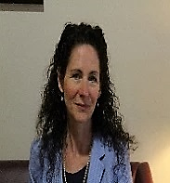
The NYSDSC Planning Committee would like to welcome each of you to the New York State Disability Service Council’s Fall 2017 Meeting.
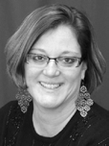
This year’s theme, “Building Resilience, Empowering Lives”, reflects our commitment to the health and vitality of our members. Resilience and empowerment recognizes values, respects, and promotes inclusion and positive outcomes. This meeting will empower NYSDSC membership to become efficient in problem solving and build a sense of togetherness through professional development and communication of state and national standards.
Catherine Carlson, Columbia-Greene Community College
Annette Renee Jenner-Matthews, Syracuse University
Tamara Mariotti, Mohawk Valley Community College
Nancy Carr, Onondaga Community College
Don Pool, Jamestown Community College
Loren Nowak, Clarkson College
Grace Costello, Mohawk Valley Community College
Jhony Nelson, LaGuardia Community College
Melissa Soules, Finger Lakes Community College
Jean Vizvary, SUNY New Paltz
Daniel Chan, Hunter College
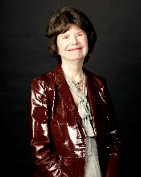
We have attempted to provide you with sessions that will validate your challenges, empower you to build resilience, internally and externally, and help you build a well-balanced professional life.
In addition to self-care, we have coordinated an engaging agenda that will address the ins and outs of being a disability services professional, which we hope you find useful. We hope you will take back what you have learned to your campuses, share with colleagues, and use them to promote disability awareness.
We have appealed to our partners in The New York State Education Department and ACCES-VR to advise you and update you on initiatives that impact the educational careers of our students.
Lastly, we have provided you with relevant “hot topic” discussions regarding Web Site Accessibility and Autism that we hope will serve to strengthen your expertise.
We truly appreciate your participation and more importantly, wish you a very productive and rewarding stay!

